To go through the EBICS Payment Process you should setup the Following

**Step 1:**

* Go to <https://c2ttest.azurewebsites.net/SecuritySetting/PaymentSecurity/Technical/ThreeSkeyConfiguration.aspx>
* Create a rule as the following

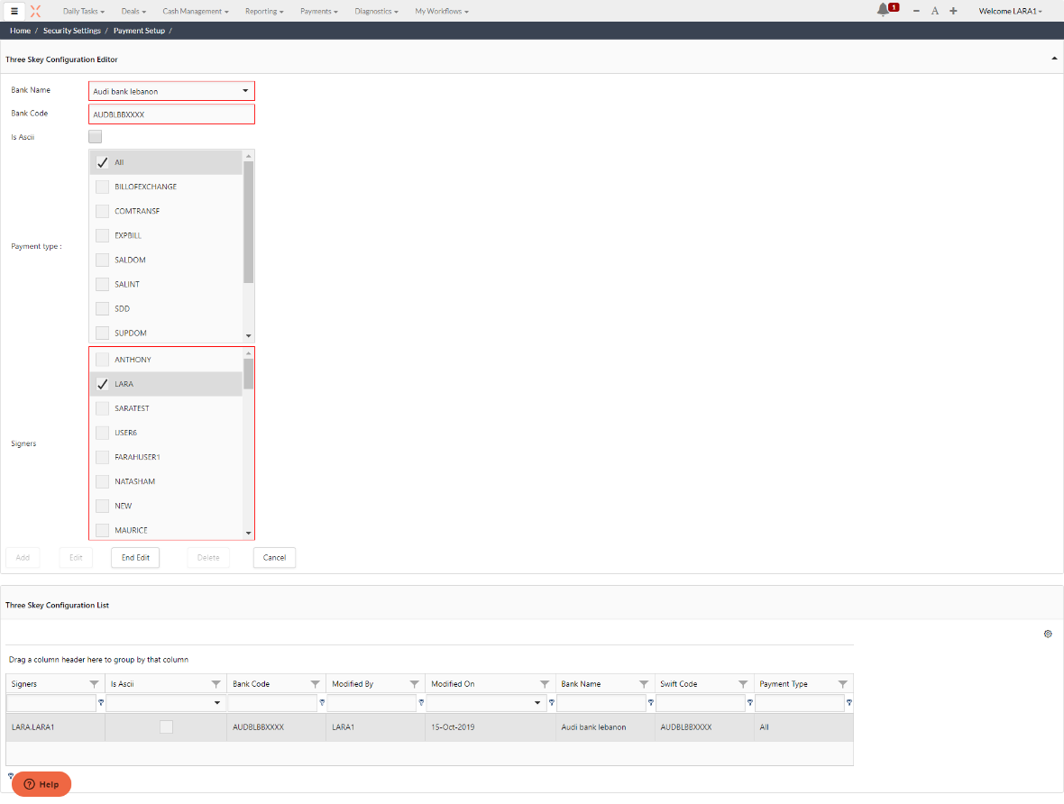

**Step 2:**

* Go to <https://c2ttest.azurewebsites.net/Payments/ThreeSkeyKeys.aspx>
* Create a key as the following

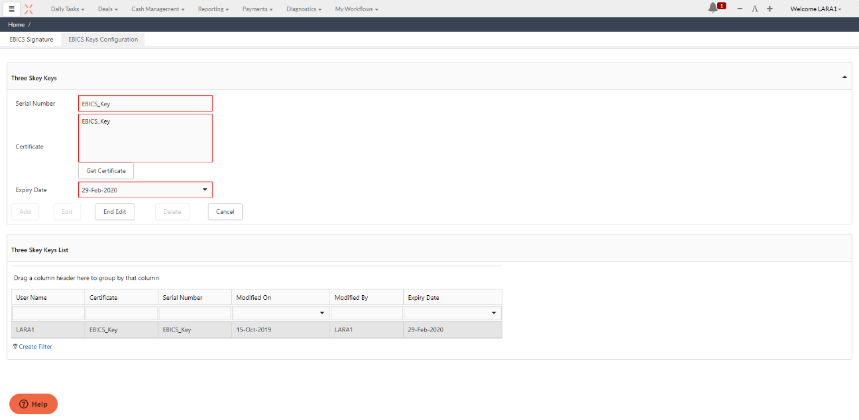

**Step 3:**

* Go to <https://c2ttest.azurewebsites.net/SecuritySetting/ApplicationSecurity/EBICSSettings.aspx>
* Create a rule as the following

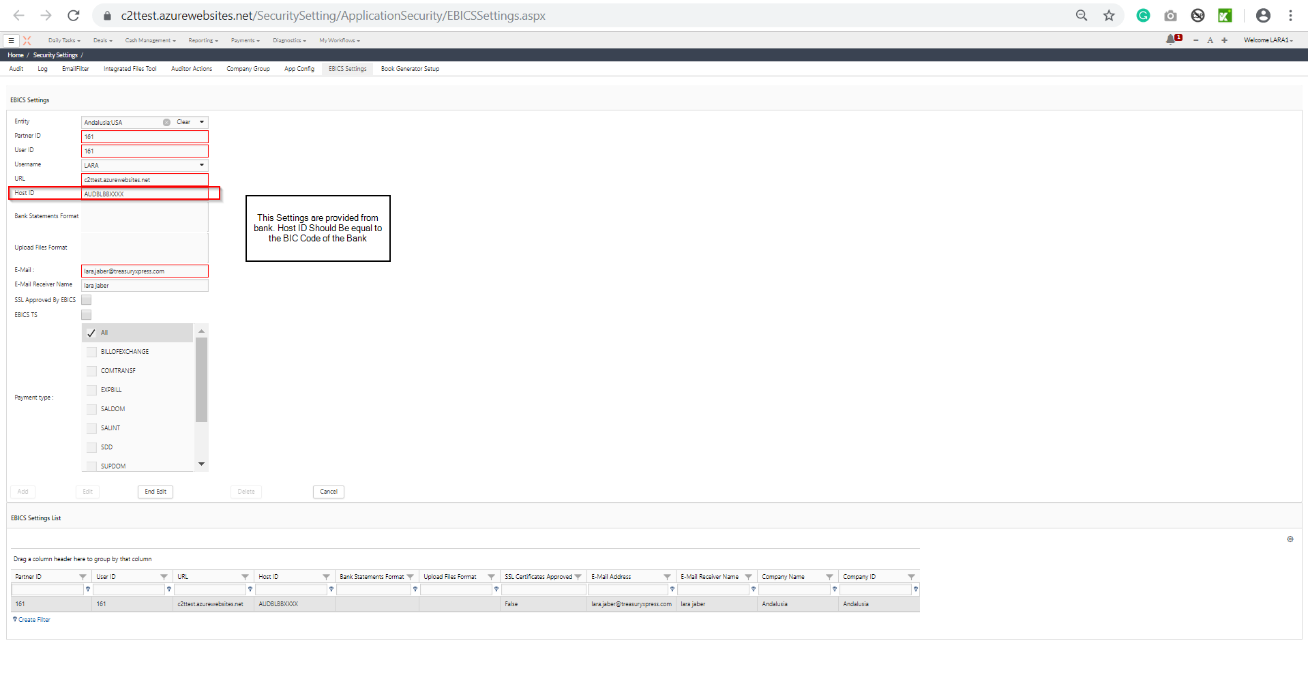

**Step 4:**

* Go to Payment Editor and create a payment

**Step 5:**

* Go to <https://c2ttest.azurewebsites.net/Payments/paymentvalidation.aspx>
* Validate the payment

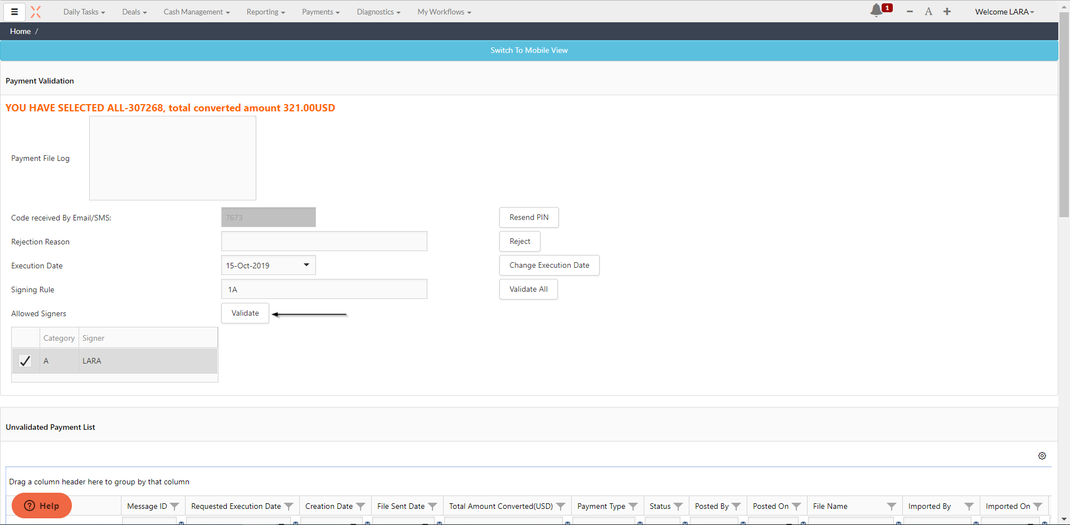

**Step 6:**

* Go to <https://c2ttest.azurewebsites.net/Payments/EBICSSignature.aspx>
* Sign the payment

